

Graduation Project Report

Faculty of Information Technology and Computer Science

Department of Business information technology

Semester: First Semester, 2025-2026

Project Title: Taste-Lens
Team Members:
- Hashem Alrabee (Team Leader & Data Analyst)
- Asem Abu Diak (Database Developer)
- Heba Mahaftha (Front-End Developer)
- Ekhlas AL-khaldy (Back-End Developer)
Supervisor
- Dr. Ala-deen Hamoud

Taste_Lens Project Documentation

1_Project Description, Objectives, and Targeted Audience
Project Description:
Taste-Lens is an intelligent cross-platform application (mobile and web) powered by Artificial Intelligence (AI), designed to help users discover food and entertainment experiences that match their mood, preferences, and location.
The goal is to bring technology closer to human emotions and behaviors by offering personalized, adaptive, and context-aware recommendations.
The platform leverages AI-driven analysis to understand user moods, habits, and feedback, creating a seamless experience that connects people with dining and leisure options that truly fit their lifestyle.

Objectives:
- Utilize AI to analyze users’ moods, preferences, and locations to suggest suitable food and leisure experiences.
- Enhance user experience through continuous personalization and adaptive learning powered by data and user feedback.
- Support local businesses by connecting them with interested customers through intelligent recommendations.
- Integrate mapping and location-based technologies to improve contextual accuracy.
- Develop a self-learning recommendation system that improves over time.
- Combine technology, creativity, and business innovation to achieve a positive social and economic
Targeted Audience:
- Young adults (ages 18–40) who enjoy exploring new food and entertainment options.
- Individuals who often find it difficult to decide where to eat or what to do.
- Tourists seeking smart, personalized local recommendations.
- Local restaurants, cafés, and entertainment venues aiming to attract more customers and increase visibility.
- Food and entertainment lovers looking for new, data-driven experiences in their city.

2. Methodology and Expected Outcomes
Methodology:
- Requirement Analysis:
Collect user needs and analyze both functional and non-functional requirements through surveys and interviews.
- System Design:
  - Develop DFDs, use-case diagrams, and conceptual models to represent workflows and data relationships.
  - Design a responsive interface using tools such as Figma or Adobe XD, ensuring compatibility across mobile and web platforms.
- AI Model Development:
  - Implement models for mood and preference analysis using AI and machine learning.
  - Continuously refine these models using user interactions and feedback.
- Integration:
  - Connect the AI engine with the front-end (React.js for web, Flutter/React Native for mobile) and the backend (Node.js/Django).
  - Integrate with APIs (e.g., Google Maps) for real-time, location-based recommendations.
- Testing and Evaluation:
  - Conduct usability, performance, and functional testing to ensure system reliability.
  - Use A/B testing and analytics to improve recommendation accuracy through feedback loops.
Expected Outcomes:
- A fully functional intelligent system that recommends restaurants and entertainment activities based on mood, preferences, and location.
- A cross-platform, user-friendly interface offering smooth experiences on both mobile and web.
- Improved recommendation accuracy over time using feedback and adaptive AI.
- A dynamic, categorized database of restaurants and entertainment venues.
- A smart ecosystem that enhances lifestyle decisions while supporting local businesses and digital transformation.

3. Requirement Specifications and Analysis
Functional Requirements:
• Users can register and log in securely.
• Users can input their mood or preferences manually or through quick selections.
• The system analyzes text input using AI models to determine mood and interests.
• The system displays personalized recommendations based on user profile, mood, and location.
• Users can rate recommendations, which are stored to refine future suggestions
Non-Functional Requirements:
- Performance: Average response time should not exceed 3 seconds per request.
- Usability: The interface must be simple, visually appealing, and intuitive.
- Scalability: The platform must handle large numbers of concurrent users and data points.
- Security: Ensure user data privacy and secure authentication for all users.
Analysis:
The system combines AI-based mood and preference analysis with a structured database of categorized restaurants and entertainment venues.
By integrating location services (e.g., Google Maps API) and continuous learning models, Taste-Lens provides highly personalized, real-time recommendations that evolve with each user’s interaction.

4_Business Functions and Structure

A. Data Flow Diagram (DFD – Level 0)
Entities:
- User
- Taste-Lens System
- Restaurant & Activity Database
- AI Recommendation Engine
Process Flow:
- The user inputs or selects their mood and/or preferences (e.g., cuisine type, activity style).
- The system processes and analyzes user data (mood, preferences, and location) using AI.
- The system queries the database and the AI engine for the best-matching recommendations.
- The system displays personalized results (restaurants and activities) to the user via mobile or web.
- The user rates or provides feedback, which is stored to improve future recommendations through

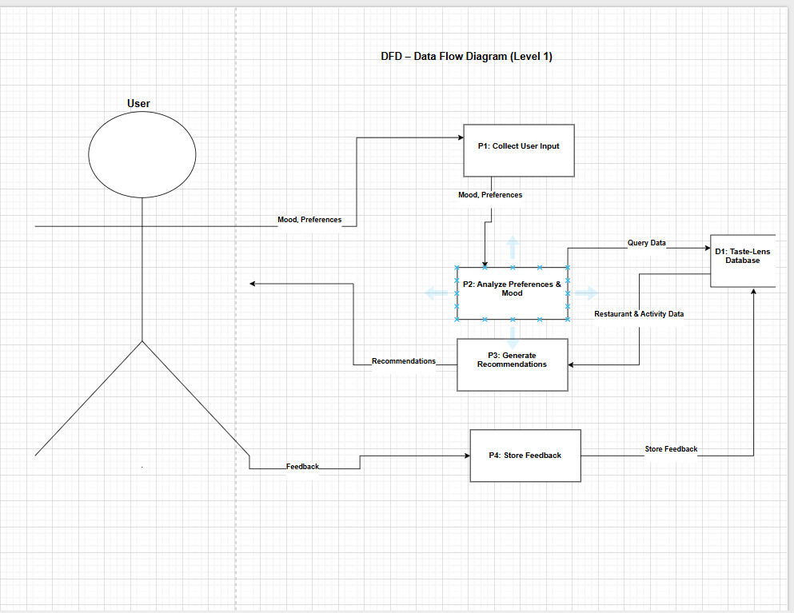

B. Use-Case Specifications
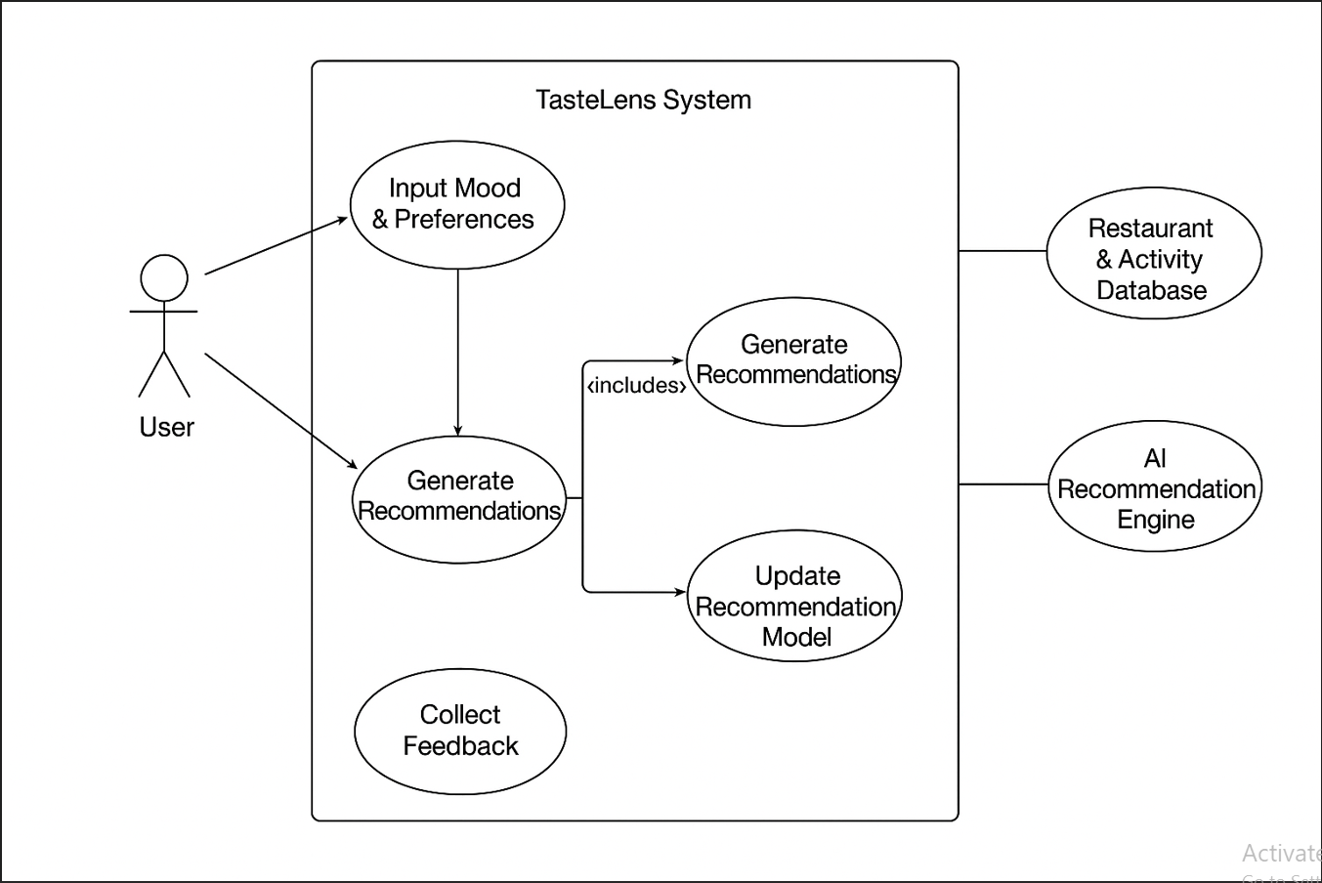

C. Conceptual Design (ER Diagram)
Main Entities:
1. User
- User-ID (PK)
- Name
- Email
- Mood
- Preferences
- Location
2. Restaurant
- Restaurant-ID (PK)
- Name
- Type
- Location
- Rating
3. Activity
- Activity-ID (PK)
- Name
- Type
- Location
- Rating
4. Recommendation
- Rec-ID (PK)
- User-ID (FK)
- Restaurant-ID (FK)
- Activity-ID (FK)
- Date
- Score
Relationships
- User – Recommendation
  - One User can have many Recommendations
  - (1 → M) relationship
- Restaurant – Recommendation
  - Each Recommendation is linked to one Restaurant
  - (M → 1) relationship
- Activity – Recommendation
  - Each Recommendation is linked to one Activity
  - (M → 1) relationship
- AI Engine (Conceptual note)
  - Uses User Feedback (Score) from Recommendation to improve future suggestions
  - Not a physical entity, but a process for refinement

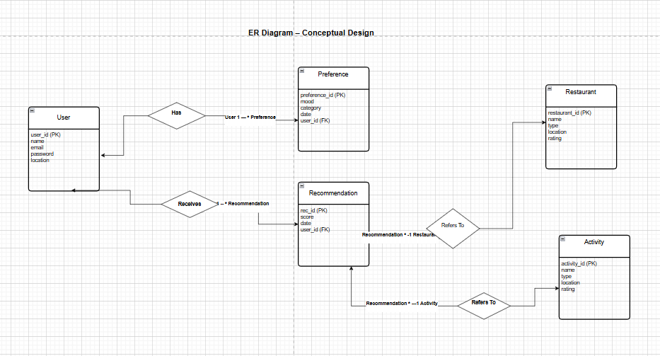

D. logical Design (Relational Schema)
User(User-ID PK, Name, Email, Mood, Location)
Restaurant(Restaurant-ID PK, Name, Type, Location, Rating)
Activity(Activity-ID PK, Name, Type, Location, Rating)
Recommendation(Rec-ID PK, User-ID FK, Restaurant-ID FK, Activity-ID FK, Date, Score)

